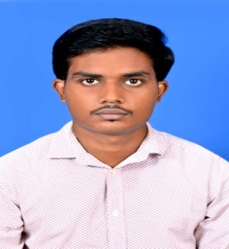
MUKTIKANTA MOHAPATA
Email - muktikantmohapatra05@gmail.com
Phone - +91 9861234043
OBJECTIVE

- Seeking a challenging position in which I can utilize all of my knowledge for the better future of the company.

ACADEMIC PROFILE

- Graduate (B.Tech)
Synergy Institute Of Technology, Bhubaneswar
Electrical Engineering
CGPA – 7.0

- Intermediate (CHSE)
Christ College, Cuttack
Percentage – 57

- Matriculation(HSE)
Seva Sikshya Niketan, (Cuttack)
Percentage – 69

SKILLS

COMPUTER SKILLS
- Operating System
Windows 7, windows XP
- Language
C
TECHNICAL SKILLS

- PLC Programming
- SCADA

SPECIAL SKILLS

- Adaptable Nature
- Creative & Innovative Skills
- Fast Learner & Reliable

CONCLUSION

I hereby confirm that the above information is true to the best of my knowledge.

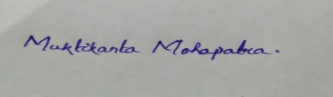

PLACE: Signature

